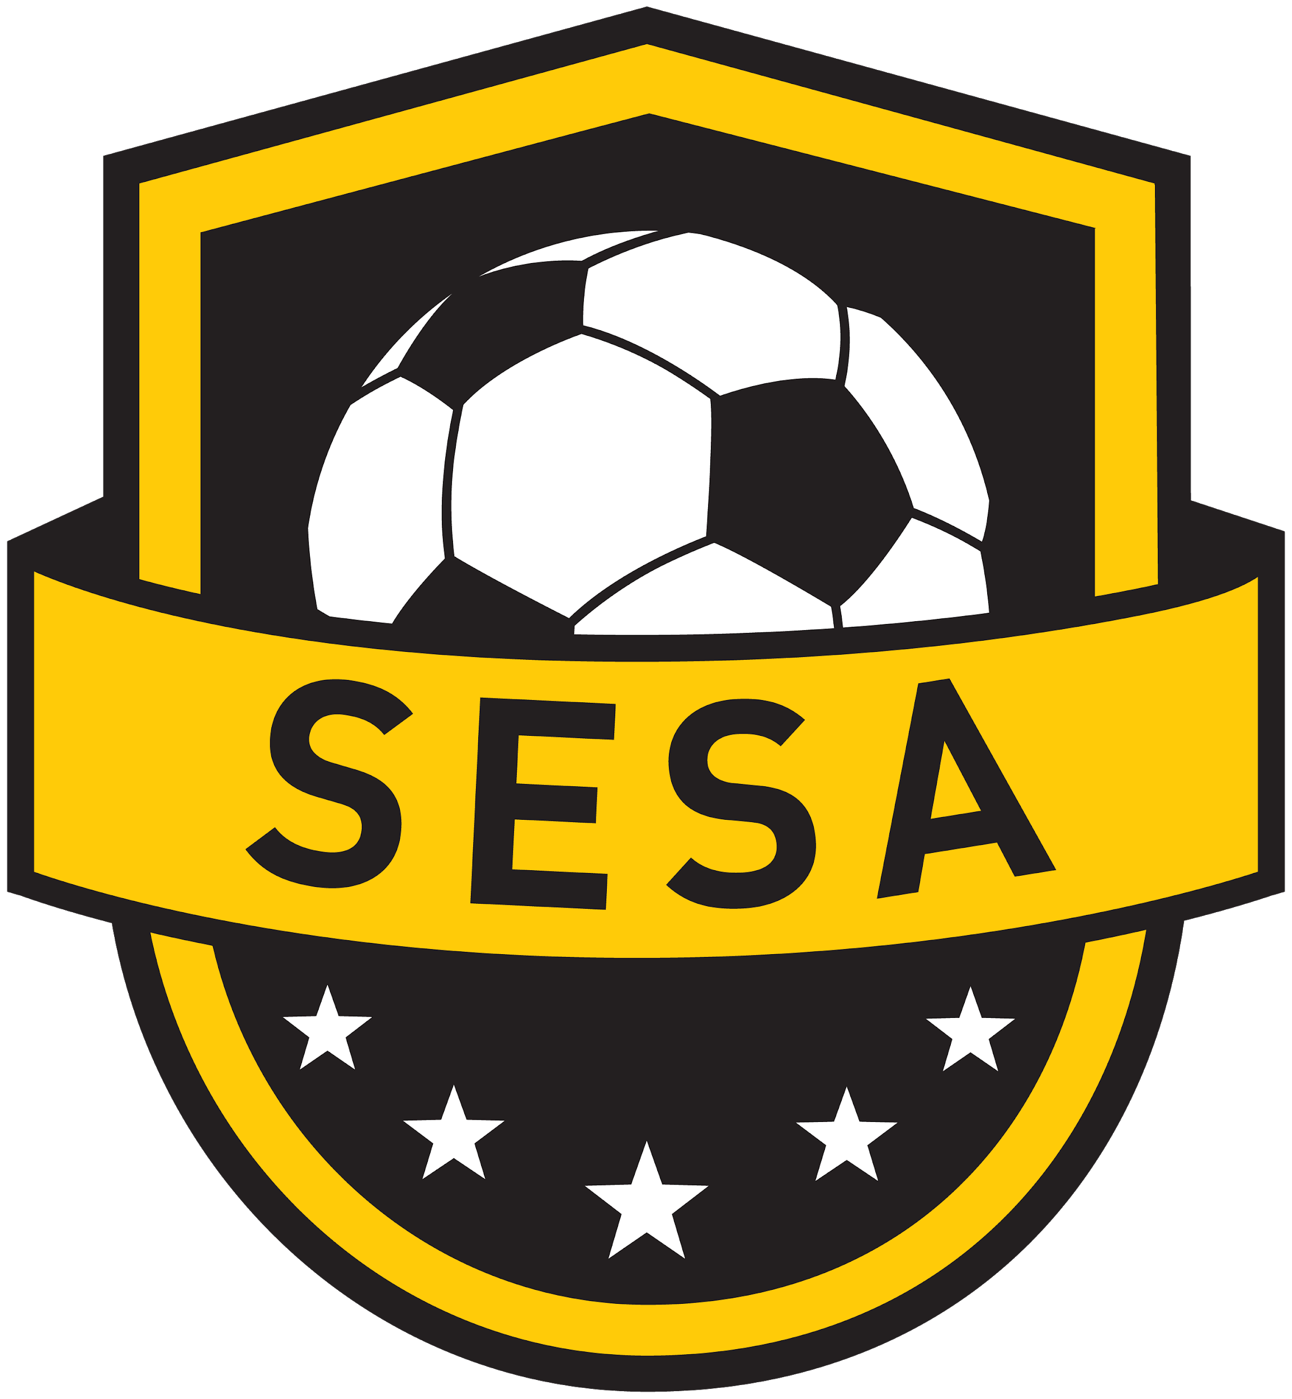

To Develop A Passion For Soccer In Our Community

I will,
· Encourage good sportsmanship of all players and peers.
· Accept the results of all games encouraging players to be gracious in victory and to turn defeat into victory by working to improve.
· Appreciate that winning is an outcome we train to achieve and not the sole purpose of youth soccer matches.
· Act as a positive role model by showing exceptional support for all players, coaches and game officials.
· Use my influence and authority to deter inappropriate conduct by other supporters towards officials and opponents.
· Encourage and expect my child to play within the spirit, written rules and laws of the game without the intent of causing injury to an opposing player.
· Emphasize and reinforce that the game is played for fun and whilst we strive to win, the outcome is secondary to player development.
· Support coaches, game officials and other volunteers who spend valuable time with the players.
· Abide by the rules established by the associations and leagues that SESA is affiliated with.
· Walk away from the field of play if I feel that I may not be able to control my emotions or my actions.

I will not,
· Engage in any physical or verbal confrontation with players, coaches, referees or supporters.
· Criticize, harass, heckle or otherwise disrespect players, coaches, supporters and referees.
· Incite players, coaches or other supporters into conduct towards officials that is contrary to the Laws of the Game.
· Approach a coach, parent, or referee, immediately after a game to discuss an issue I have. Any issues must be dealt with in a professional manner via phone call or email the next day.
· Coach or instruct the players from the sidelines.
· Negatively discuss players, coaches or parents with or in the presence of any players, most importantly my own.

By receipt of this document and registering with the SESA , I acknowledge understanding of the above Code of Conduct. Furthermore, I acknowledge that any infraction of the Code is subject to disciplinary action

Sign & Print ……………………………………………………………………..

